CODE:
import numpy as np
from scipy.stats import chisquare

# Example: Chi-Square Goodness of Fit Test
observed = [25, 20, 30, 25] # Observed frequencies for Math, Science, English, History
expected = [25, 25, 25, 25] # Expected frequencies (equal distribution)

# Perform Chi-Square Goodness of Fit Test
chi2, p = chisquare(observed, expected)

print(f"Chi-Square Value: {chi2}")
print(f"P-Value: {p}")

# Interpretation of the result
if p < 0.05:
print("Reject H₀: There is a significant difference between observed and expected frequencies.")
else:
print("Fail to reject H₀: There is no significant difference between observed and expected frequencies.")

OUTPUT:
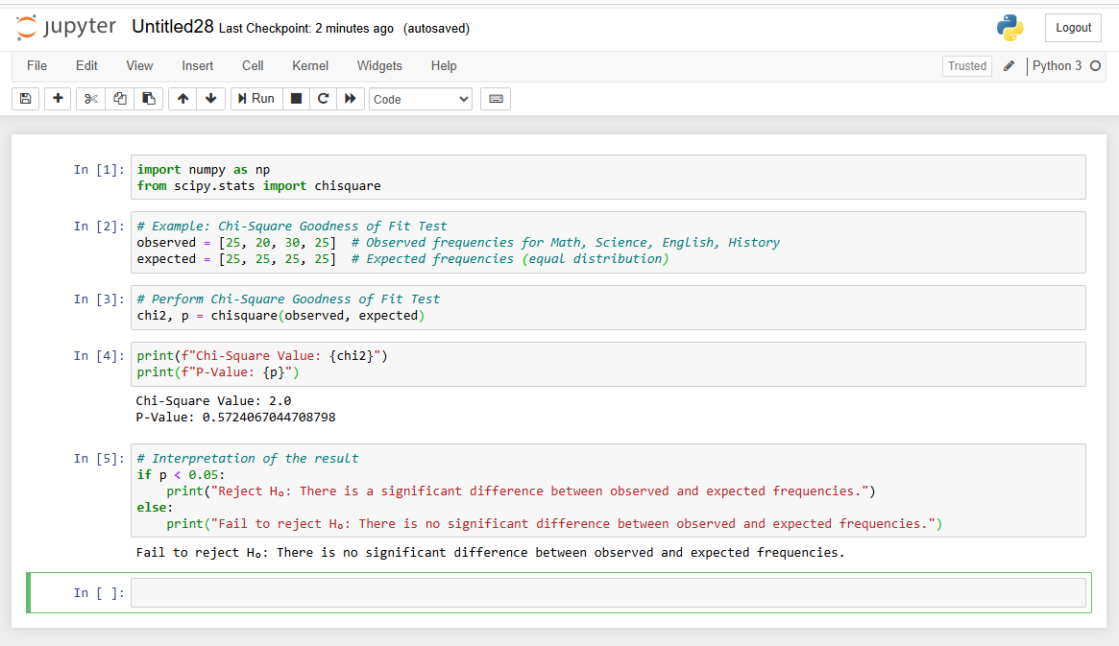

CODE:
import pandas as pd
from scipy.stats import chi2_contingency

# Example: Chi-Square Test of Independence
# Gender vs. Shopping Preference (Online/Offline)
# Create a contingency table (observed frequencies)
data = {
"Online": [30, 10], # Male, Female for Online shopping
"Offline": [20, 40] # Male, Female for Offline shopping
}
df = pd.DataFrame(data, index=["Male", "Female"])

# Perform Chi-Square Test of Independence
chi2, p, dof, expected = chi2_contingency(df)
print(f"Chi-Square Value: {chi2}")
print(f"Degrees of Freedom: {dof}")
print(f"P-Value: {p}")
print(f"Expected Frequencies:\n{expected}")

# Interpretation of the result
if p < 0.05:
print("Reject H₀: There is a significant relationship between gender and shopping preference.")
else:
print("Fail to reject H₀: There is no significant relationship between gender and shopping preference.")

OUTPUT:
